REPORT:

Capex is short for capital expenditure. Capital expenditure is the cost a business incurs to acquire assets that will provide benefits beyond the current year. CapEx is also referred to as PP&E, which stands for Property, Plant, and Equipment.

Globalization is not a brand-new issue, it continues over 50 years. Nevertheless, each new decade globalization creates new opportunities for business. A relatively new issue in international business is that global business became available for small and medium size enterprises. It is based on: - Internet and digital communication tools, such as messengers, skype, WhatsApp, Zoom, DingTalk - Digital marketing Emerging markets to benefit due to China's Covid relaxations - Online sales spots: Alibaba, Amazon, Taobao, JD - Efficient and fast logistics and delivery What is really new in 21st century is that now even a small business is able to export goods and services and develop business globally.

Automation of logistics makes export goods more available for consumers. Personal presence in a foreign country is not obligatory for doing business anymore. Transport costs are much lower or not significant in case of export of services. Online shopping reduces costs of entering new foreign markets. Regular shopping requires physical presence in the country whereas online shopping is based on digital advertising, web platforms and delivery by post.

Nowadays there is one more significant and fast growing part in export business: global services. Spread of Internet, Social Media and digital marketing has contributed to the global development of these industries most of all. Also Read - Lo Presto! Masks, clothes, cosmetics and sanitary pads from hemp plants These are such businesses as: Digital marketing and e-commerce tools provide you with numerous opportunities of expanding your business globally.

The fundamentals of modern global marketing are: -

Digital marketing tools and E-commerce - Modern technologies of logistics and delivery - Modern communication tools - Selling web-portals, such as Aliexpress, Amazon, Taobao, JD Another significant change is that an offline presence in a targeted country is less required for international business than before. A combination of digital marketing tools, electronic communication with real offline meetings and negotiations helps to replace costly subsidiaries or offices in other countries. Also Read - Fintechs, the friendly guide to achieve financial freedom

Adjust your product line to foreign markets. Try to attract all types of customers! Product line should be adjusted: it's a very key to the whole export enterprise.

There are two main reasons why product line should be adjusted:

1. Because your foreign target market might be very different from your local market. Different means not only the taste and color preferences, or cultural differences, what is wide discussed on the web. It also means different channels of distribution, different types of advertising, different market niches and competition. To understand this better, a diligent market research is required, we discuss it below.

2. Because your international strategy should be tightly adjusted to digital marketing. For some companies it is not a problem, if they already have strong digital marketing in their domestic market. But many small or medium companies, especially in B2B, have more traditional relations with customers. For example, individual relations, telesales, participation in tenders, revolver sales to the existing customers. All these barely works for export marketing (there are some exemption, we also discuss it later). Digital marketing and sales tools are typically the key to your success in exports. For all companies, starting with sales to new foreign markets, it will be better to separate export sales & marketing division from your local business.

Strategies for digital expansion-

1. Discover the best techniques.

The first thing you should do is decide which digital marketing tactics are best for your requirements. There are numerous approaches you might take, and each one's success will rely on your goals. Two techniques, though, are regarded as fundamental, so no matter what kind of business you run, you should always use them. These are social media marketing and search engine optimization.

SEO, or search engine optimization, is essential for any company looking to build an online presence. It goes beyond simply being at the top of search engine results. It basically involves posting accurate information about your business online so that both search engines and human readers are aware of what you have to offer.

Given the significance of social media marketing in the consumer market, it is also regarded as fundamental. These days, almost every prospective consumer has a social media account, making it a fantastic channel for disseminating your marketing messaging. Consideration should also be given to affiliate marketing, video advertising, email marketing, and content marketing.

Expedite expansion by outsourcing-

An IT team travelling abroad is a significant undertaking. Even if it takes a long time to pay off, the financial rewards are immeasurable when it does.

It's crucial to enter new nation markets in the early stages of expansion in a cost-efficient and significant manner.

For taking these new risks, outsourcing is an essential resource. Employer of Record Services enables businesses to test the waters without having to deal with the time- and money-consuming bureaucracies associated with setting up shop abroad.

Your company's requirement for new personnel must be met as it expands in a way that is both efficient and affordable. As a result, outsourcing will still be an important tool for cutting costs.

There are around 130,000 contractors working for Google who are handled and paid by staffing and Employer of Record companies including Adecco, Accenture, and Cognizant.

Over 50% of Google's employees are actually outsourced, as according to recent reports.

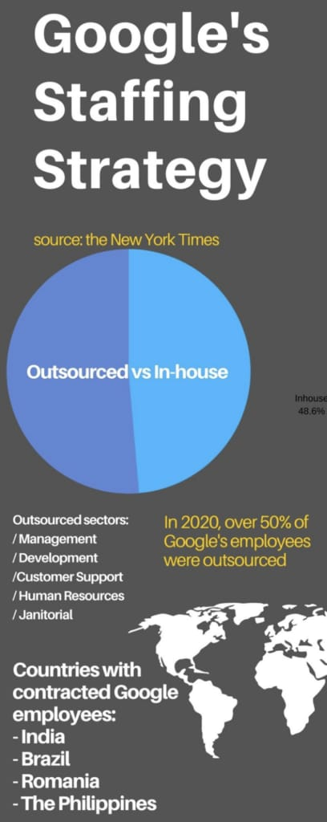

Make smart decisions with your data**-**

**Three of the most rapidly expanding businesses in the last ten years—Facebook, Netflix, and Google—raced ahead by gathering, analysing, and utilising massive amounts of data. These companies, including Google, may be data-driven enterprises, according to certain arguments. However, Netflix is not the only streaming service available.**

**Accessibility -**

**It is crucial to have a Google Analytics and Google Search Console view for each country you wish to enter in order to analyse local data when expanding internationally. The website's content, which needs to be localised in the nation's language, is the second crucial component. For instance, an English-language website targeting the French market may face severe penalties for conversions, quality ratings, etc. In keeping with the subject matter, translations alone won't cut it when it comes to reviewing your SEO with native speakers who are SEO experts. Additionally, a regionally optimised website will benefit your SEM, conversion rate, brand perception, and many other significant eCommerce factors. Last but not least, people utilise Google search differently based on the nation and without an ad hoc keyword strategy specific to the country, you can miss many opportunities.**

**Target - You must have a distinct picture of your target customer. Given that they vary depending on your business role, there may be more than one. These are crucial in defining the final phase of successful digital marketing: channel selection and targeting. Although there are sometimes many commonalities, buyer personas might vary from region to country.**

**Marketing channels - After putting these components in place, we may choose which marketing channels to use. The best marketing mix must be chosen in light of the many factors already in place and to accommodate a local strategy.**

**Working with local native speaker experts is essential when it comes to SEO and digital ads, whether they are employed in-house or by an agency. Duties like keyword research, as well as creating content, metadata, ads copy, and other related tasks, must be carried out by native speakers. Performance will almost certainly suffer if translations are used for these jobs.**

**Similar to social commerce. Native content and creative development is a necessity for a profitable investment in this channel, and having local experts empowers a business to generate effective ad text.**

**Identifying the right platform to advertise on, for example, for affiliate marketing, will differ from country to country. For example, Rakuten is big in the UK market but small in Italy. While Snapchat is massive in the US, strong in France and the UK, but still really small in Italy and Spain.**

**Successful international expansion requires businesses to either build an internal international team with local expertise or find a partner (agency) with this local expertise in-house. Whichever way you approach it, it is crucial to adequately invest in your digital marketing strategy because your competition will be.**

**Keeping factors such as market size, GDP growth, competition level, cultural differences and legal landscape in mind, here are some critical ways to target specific countries for global expansion:**

**Ways to target specific countries for global expansion**

**1. Prioritize nations with large software markets**

**According to Gartner Digital Markets’ 2022 Global Software Buyer Trends Survey[*], 66% of businesses globally spent more on software in 2022 compared to 2021, and the numbers will only continue to increase. The reason? Enterprise software is becoming an increasingly essential part of businesses, as it helps automate and streamline operations.**

**With this in mind, prioritize countries such as Japan, Germany, Brazil and France that have large software markets. These countries offer the greatest potential for revenue growth and market share expansion by providing a larger addressable market for your software company.**

**2. Research your target country's business and cultural norms**

**Cultural differences can significantly impact how you operate in different countries. For instance, Asian countries have different cultural norms than European or North American countries, so what works in one country may not necessarily work in another.**

**Research a country's business and cultural norms to understand how to tailor your offerings to better meet the needs of local customers by understanding their preferences and expectations. With a better understanding of the local business environment, you'll be better positioned to identify potential prospects and build strong relationships with them.**

**3. Develop a marketing strategy that resonates with local buyers**

**Once you decide which countries to target for expansion, emphasize creating a well-thought-out marketing strategy for local buyers. This is important because how you market and sell your products and services in different countries might vary considerably. For instance, what works in the United States might not work in China, and vice versa.**

**Some factors you'll need to consider when developing your marketing strategy include the local language, culture, customs and norms. Leverage market intelligence tools to gather insights into the local market, such as consumer preferences and buying habits, to ensure your marketing strategy is effective.**

**Developing a market research strategy can deploy directly on physical market as well as digital presence.**

Harshal Andhale

MBA TECH EXTC

70431119004.

MANAGEMENT PREFERENCE: Marketing.